1.Harshad number
#include <iostream>
using namespace std;
int main()
{
int n, temp, digit, sum = 0;
cin >> n;
temp = n;
while (temp > 0)
{
digit = temp % 10;
sum = sum + digit;
temp = temp / 10;
}
if (n % sum == 0)
cout << "Harshad Number";
else
cout << "Not a Harshad Number";
return 0;
}

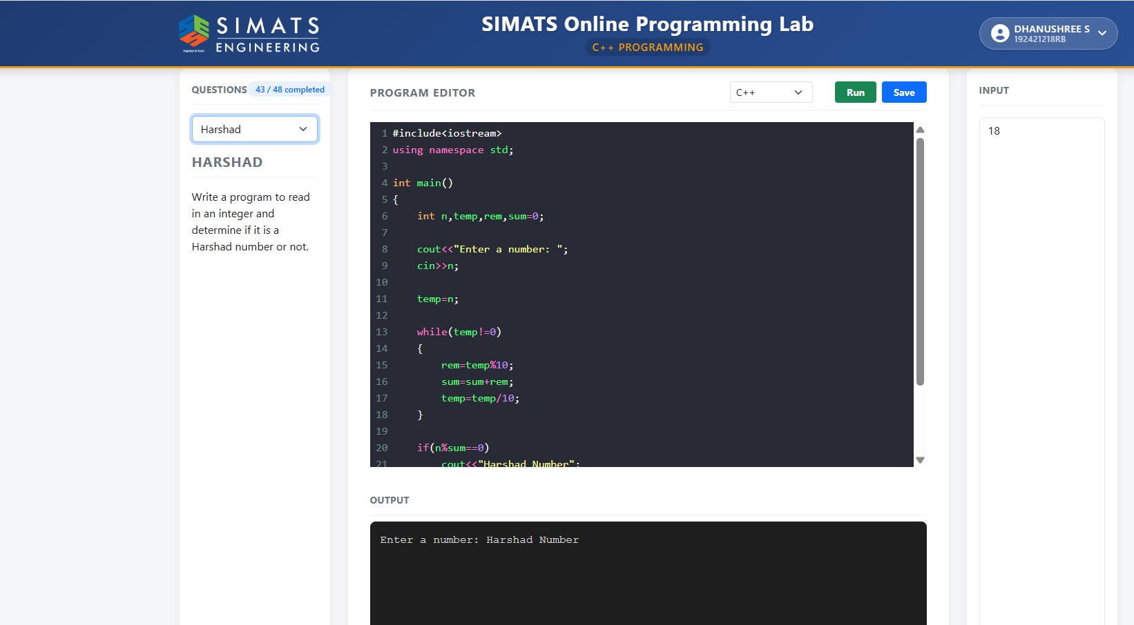

2.
#include <iostream>
using namespace std;

int main()
{
int a, b;
cout << "Enter first number: ";
cin >> a;
cout << "Enter second number: ";
cin >> b;
cout << "Before Swapping" << endl;
cout << "a = " << a << endl;
cout << "b = " << b << endl;
a = a ^ b;
b = a ^ b;
a = a ^ b;
cout << "After Swapping" << endl;
cout << "a = " << a << endl;
cout << "b = " << b << endl;
return 0;
}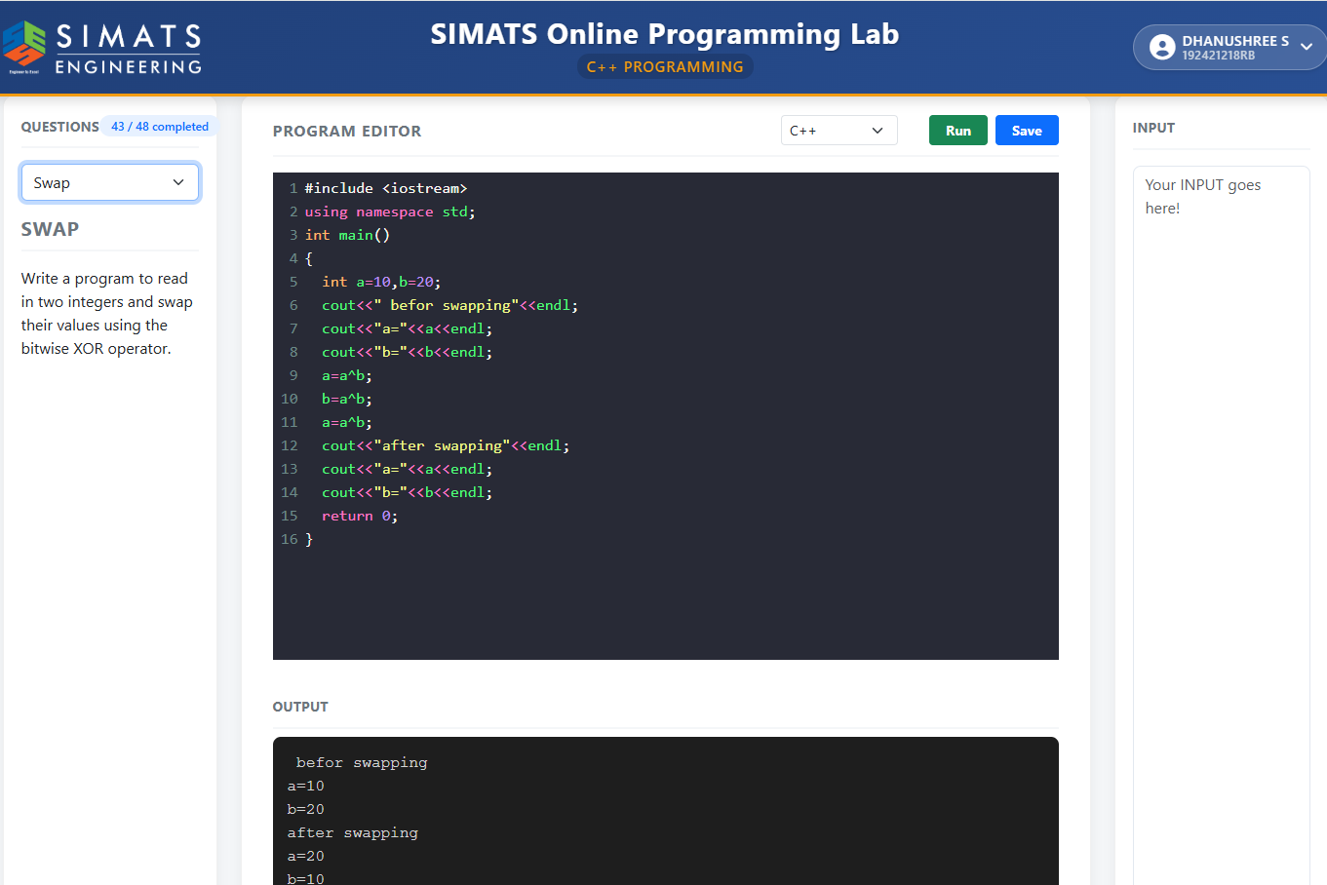3. #include <iostream>
using namespace std;
int main()
{
int i, j, n;
cout << "Enter the size: ";
cin >> n;
for(i = 1; i <= n; i++)
{
for(j = 1; j <= n; j++)
{
if(i == 1 || i == n || j == 1 || j == n)
cout << "* ";
else
cout << " ";
}
cout << endl;
}
return 0;
}
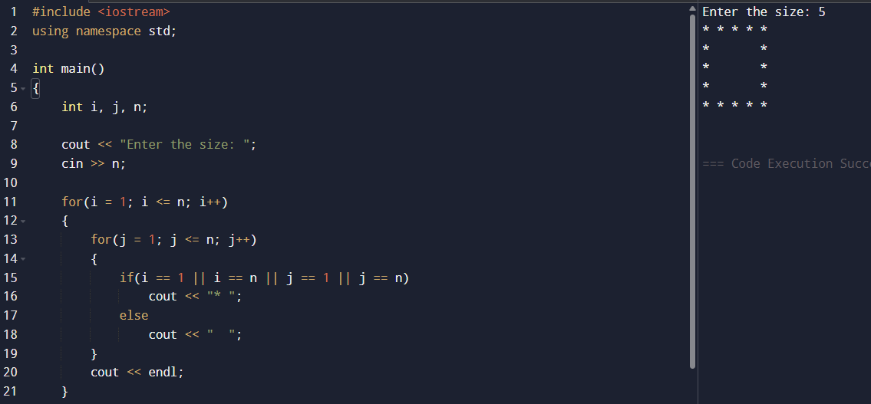4.
#include <iostream>
using namespace std;
int main()
{
int i, j, n;
cout << "Enter n: ";
cin >> n;
for(i = 1; i <= n; i++)
{
for(j = 1; j <= i; j++)
{
cout << j << " ";
}
cout << endl;
}
return 0;
}
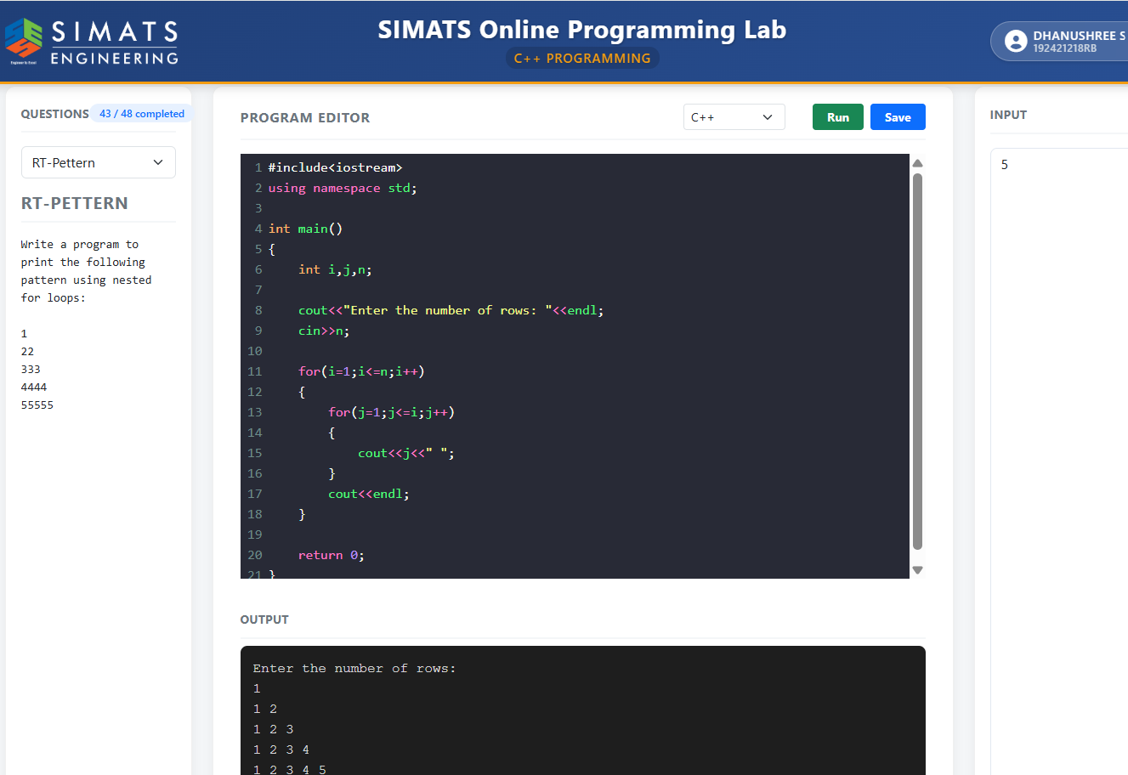
5. #include <iostream>
using namespace std;
int main()
{
int n, temp, rem, rev = 0;
cout << "Enter a number: ";
cin >> n;
temp = n;
while(temp > 0)
{
rem = temp % 10;
rev = rev * 10 + rem;
temp = temp / 10;
}
if(n == rev)
{
cout << "Palindrome Number";
}
else
{
cout << "Not a Palindrome Number";
}
return 0;
}
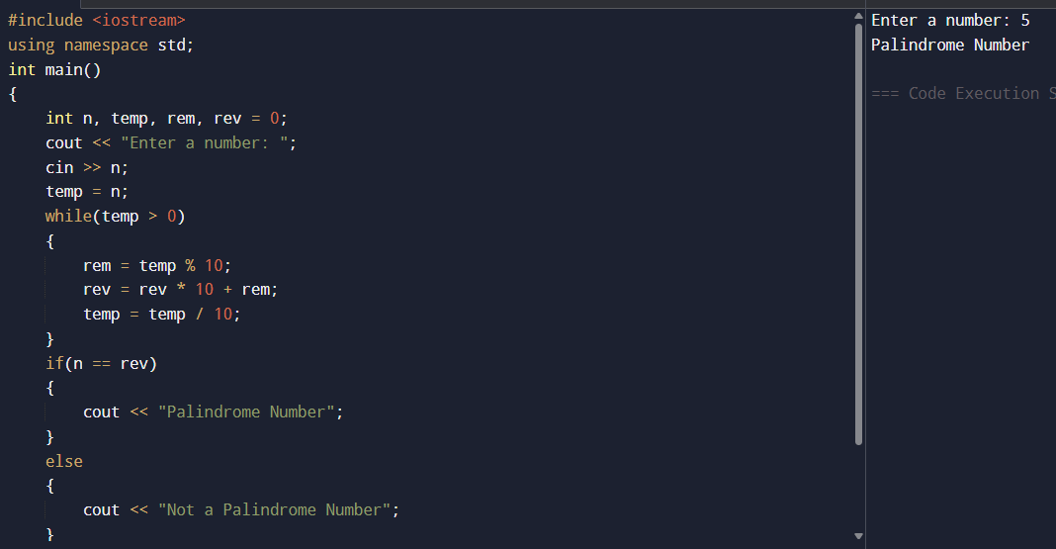

6. #include <iostream>
using namespace std;
int main()
{
int n, i, sum = 0;
cout << "Enter n: ";
cin >> n;
for(i = 1; i <= n; i++)
{
sum = sum + (i * i * i);
}
cout << "Sum of cubes = " << sum;
return 0;
}
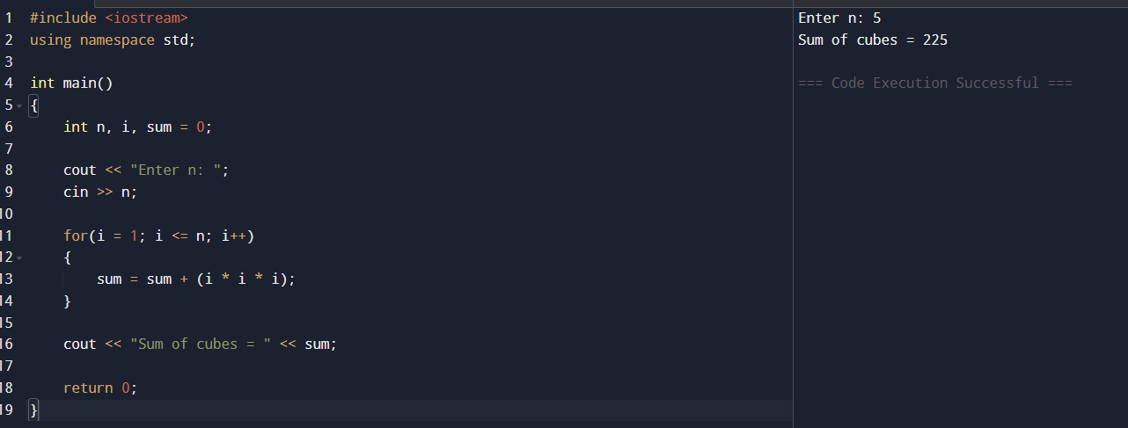
7. #include <iostream>
#include <cmath>
using namespace std;
int main()
{
int binary, decimal = 0, rem, i = 0;

cout << "Enter a binary number: ";
cin >> binary;
while(binary > 0)
{
rem = binary % 10;
decimal = decimal + rem * pow(2, i);
binary = binary / 10;
i++;
}
cout << "Decimal number = " << decimal;
return 0;
}
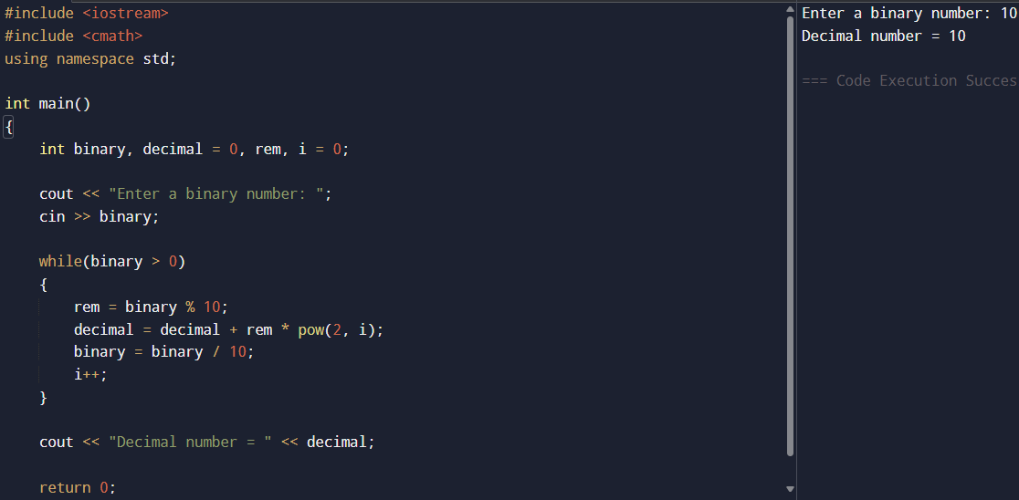
8. #include <iostream>
using namespace std;
int main()
{
int i, j, n;
cout << "Enter n: ";
cin >> n;

for(i = 1; i <= n; i++)
{
for(j = i; j >= 1; j--)
{
cout << j;
}
for(j = 2; j <= i; j++)
{
cout << j;
}
cout << endl;
}
return 0;
}
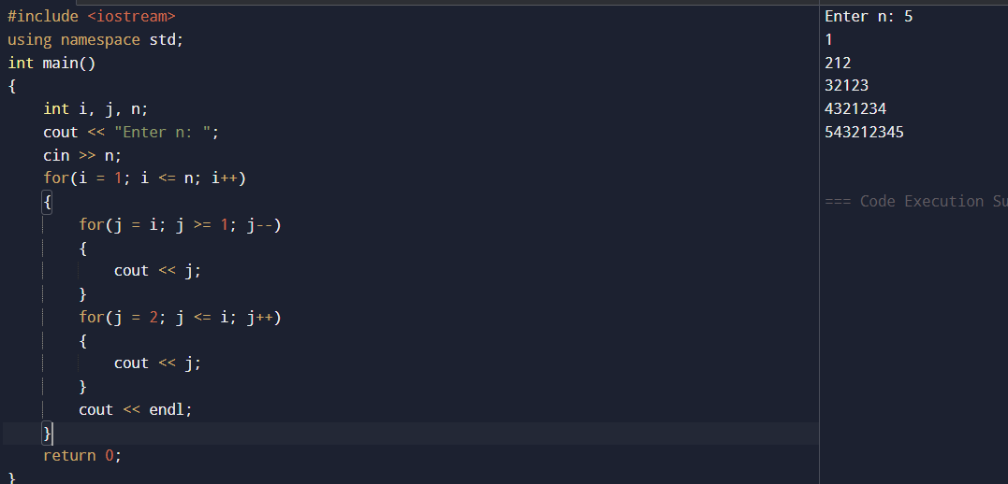
9. #include <iostream>
using namespace std;
int main()
{
int i, j, n;
cout << "Enter rows: ";
cin >> n;
for(i = 1; i <= n; i++)
{
for(j = 1; j <= n - i; j++)
cout << " ";
for(j = 1; j <= 2 * i - 1; j++)
{
if(i == n || j == 1 || j == 2 * i - 1)
cout << "*";
else
cout << " ";
}
cout << endl;
}
return 0;
}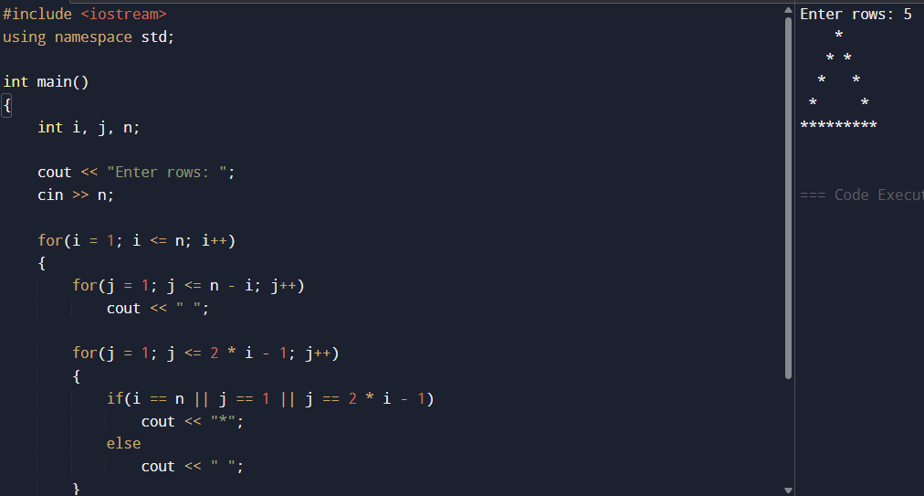
10.
#include <iostream>
using namespace std;
int main()
{
int n, i, sum = 0;

cout << "Enter n: ";
cin >> n;
for(i = 1; i <= n; i++)
{
sum = sum + (i * i);
}
cout << "Sum of squares = " << sum;
return 0;
}
